*Sent to all Members*

May 25, 2025  
  
Dear {%FName%},

A book I’ve recommended before for every parent and grandparent is “The Bully, the Bullied and the Bystander” by Barbara Coloroso.

Today I recommend it for every Rotarian and especially for club leaders and membership chairs.

Rotary International is losing members because bullying and humor at the expense of others are tolerated. May all of us have the character and decency to stand against bullying and defend those who are victims of inappropriate comments and attempts at humor.

When Rotarians stand by and fail to speak out against bullies in our midst, members resign. More importantly, feelings are hurt, the Four Way Test is violated, and friendships damaged.

No Rotarian should be talked down to, ignored, dismissed or insulted by another. And when it happens at a board of directors or club meeting, the inappropriate behavior or attempt at humor needs to be called out.

Personally, the saddest experience I’ve had in district leadership is hearing from women who have left Rotary because of bullying.

There is no place for that in Rotary. Let’s never be a bystander. I share this because if we want our children and grandchildren to reject bullying, we need to make sure we do so as well.

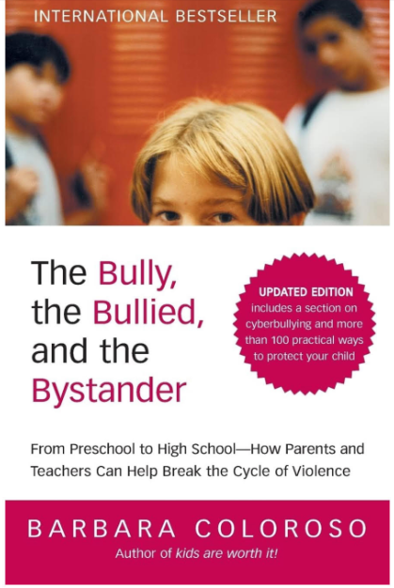

Thank you.

ROGER UTNEHMER  
Rotary District 6220  
District Governor 2024-25  
(C) 920 495 9677